**PSY 653 Module 12: Introduction to Multilevel Modeling**

**Gemma Wallace & Neil Yetz**

**April 29, 2020**

**Try it Yourself Activity**

The data file “popularity.csv” is simulated data for 2000 pupils in 100 schools. Retrieved from: https://github.com/MultiLevelAnalysis/Datasets-third-edition-Multilevel-book/tree/master/chapter%202/popularity

* pupil - The personal ID number of the pupil.
* class - The class number
* Cextrav - pupil extraversion (10-point scale). Centered at the mean (0 = Mean value).
* popular - a popularity rating on a scale of 1–10 derived by a sociometric procedure.

**Demo Activity**

1. Read in the “popularity.csv” data.

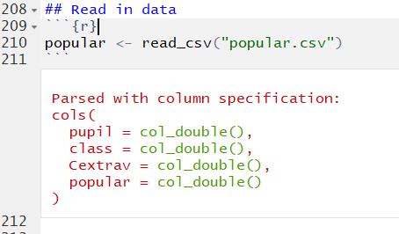

1. Factor the class variable.

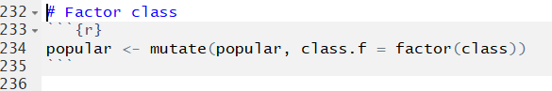

1. Perform and interpret multilevel analysis using class as a level-2 variable and Cextrav as a level-1 variable to predict popularity.
2. Interpret the results, including the intraclass correlations.

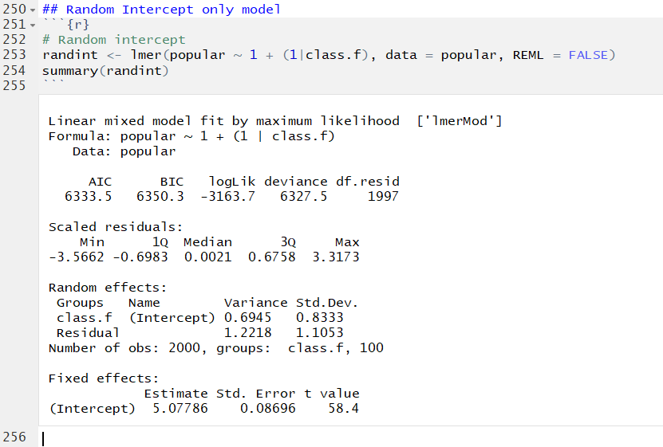

The average popularity across all classes (The mean of means) is 5.08. On average, popularity scores vary by .83 standard deviations.

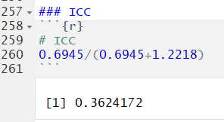

36% of the variance in popularity can be attributed to the differences between classes.

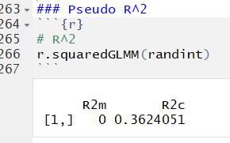

Fixed R^2: NA

Random + Fixed: 36% of the variance in popularity can be explained by the random effects in this model (No fixed effects).

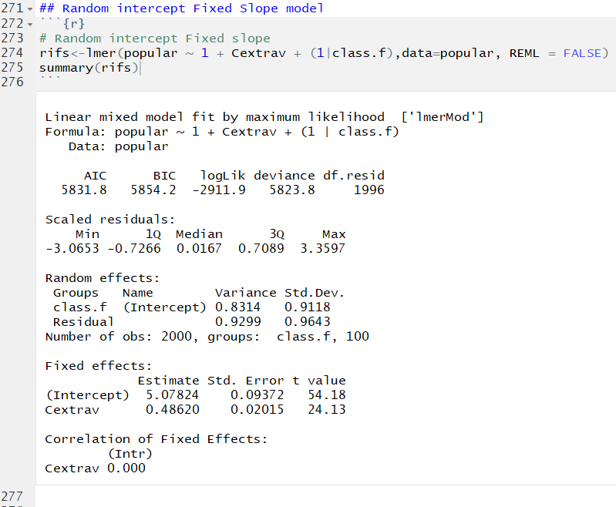

**Random intercept:** On average, class intercepts varied by 0.92 Standard Deviations

**Fixed intercept:** The average intercept, while incorporating extraversion, is 5.08

**Fixed slope:** On average, popularity increased at a rate of 0.49 units for every 1 unit increase in extraversion.

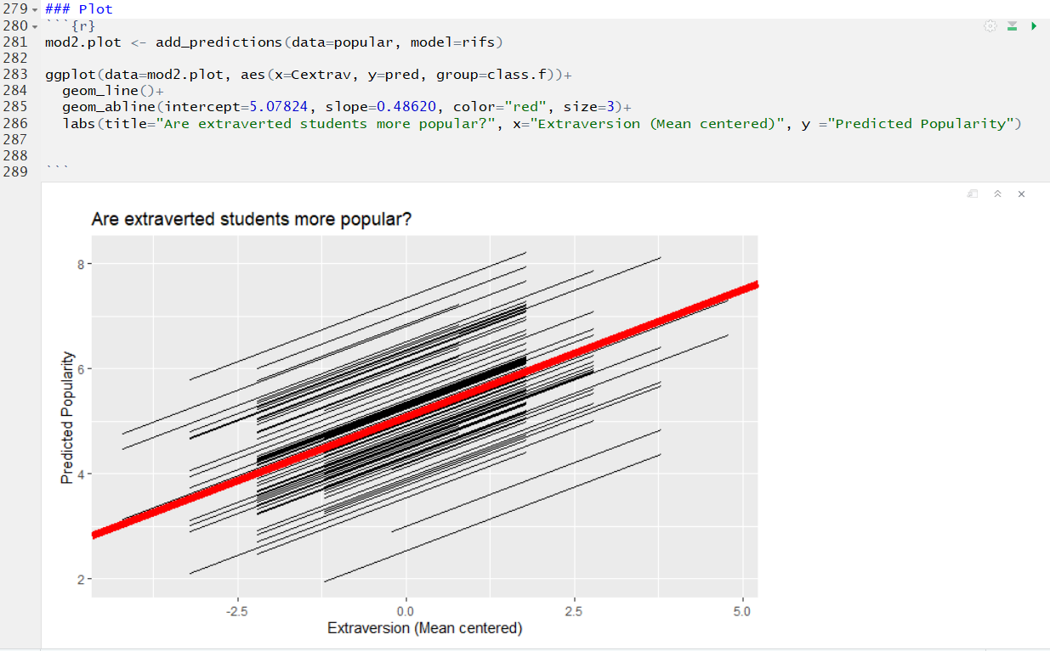

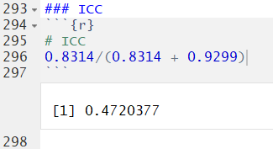

47% of the variance in popularity can be attributed to differences between classes

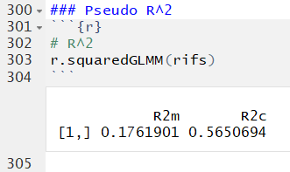

Fixed R^2: 17.62% of the variance can be explained by fixed effects alone

Random + Fixed: 56.51% of the variance in popularity can be explained by the fixed and random effects in this model

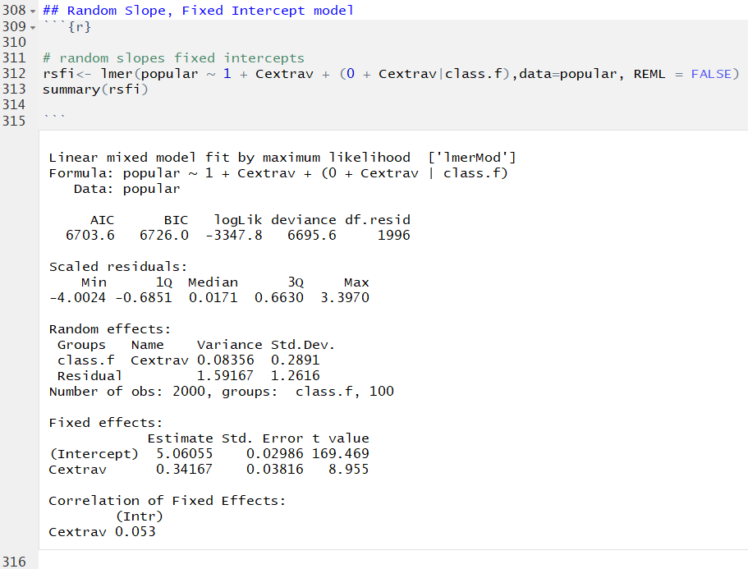

**Random slope:** On average, class slopes varied by 0.28 Standard Deviations

**Fixed intercept:** The average intercept, while incorporating extraversion, is 5.06

**Fixed slope:** On average, popularity increased at a rate of 0.34 units for every 1 unit increase in extraversion.

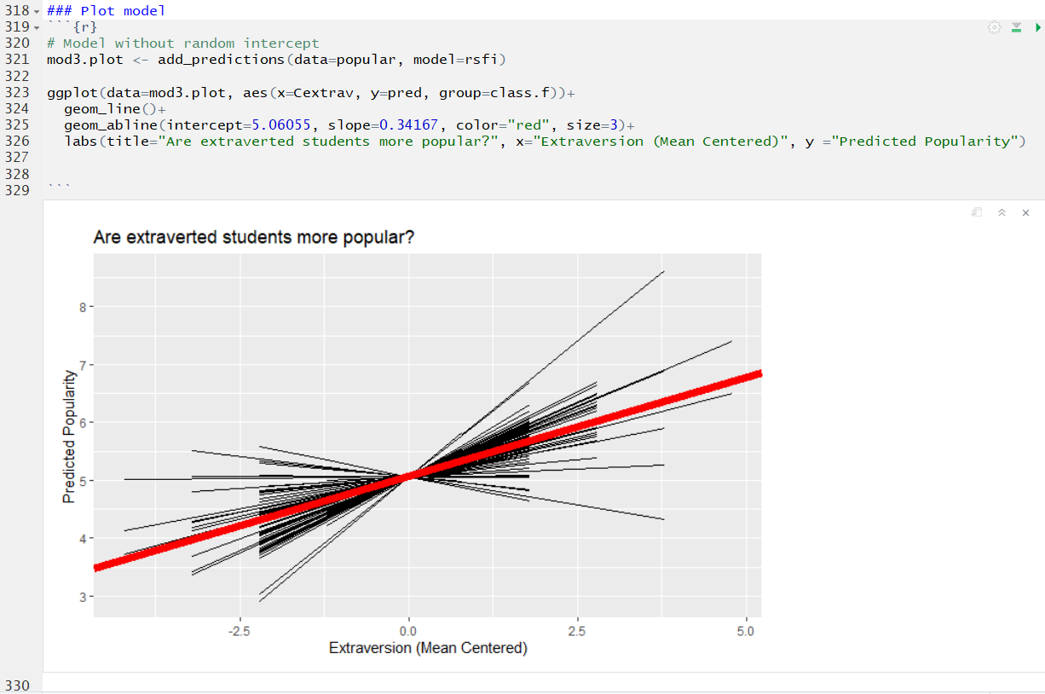

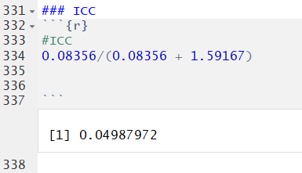

4.99% of the variance in popularity can be attributed to differences between class slopes

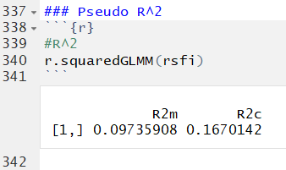

Fixed R^2: 9.74% of the variance can be explained by fixed effects alone

Random + Fixed: 16.70% of the variance in popularity can be explained by the fixed and random effects in this model

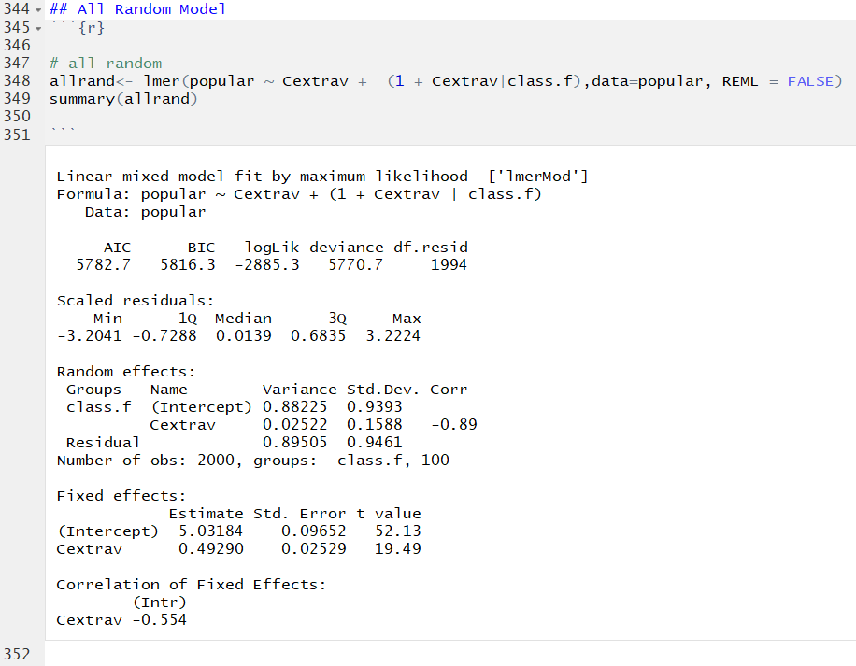

**Random intercept:** On average, class intercepts varied by 0.94 Standard Deviations

**Random slope:** On average, class slopes varied by 0.16 Standard Deviations

**Fixed intercept:** The average intercept, while incorporating extraversion, is 5.03

**Fixed slope:** On average, popularity increased at a rate of 0.49 units for every 1 unit increase in extraversion.

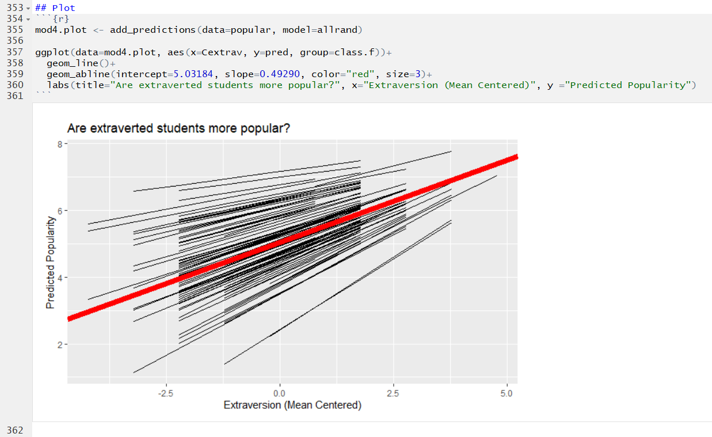

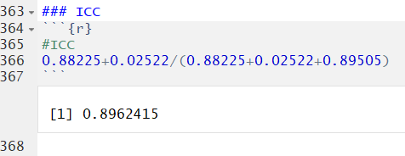

89.6% of the variance in popularity can be attributed to differences between class slopes & intercepts

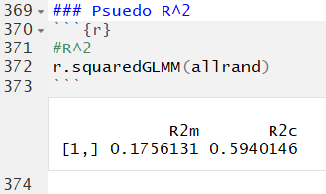

Fixed R^2: 17.56% of the variance can be explained by fixed effects alone

Random + Fixed: 59.40% of the variance in popularity can be explained by the fixed and random effects in this model

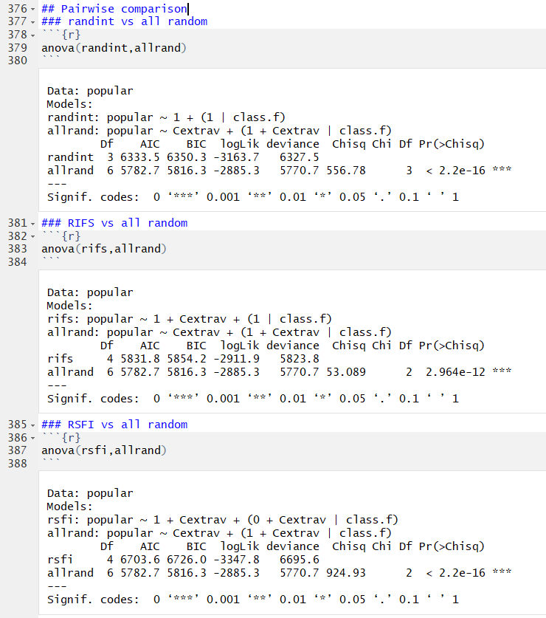

Overall, the all random model explains statistically significantly more variance than the random intercept only, Random intercept fixed slope, and Random slope fixed intercept models. Class differences seem to play a role in popularity and should be accounted for.